**EXPERIMENT - 5**

**AIM OF THE EXPERIMENT:**

To design and verify an instrumentation amplifier using multisim

**APPARATUS REQUIRED:**

PC loaded with multisim software

**THEORY:**

An instrumentation amplifier is a type of differential amplifier that has been outfitted with input buffer amplifiers, which eliminate the need for input impedance matching and thus make the amplifier particularly suitable for use in measurement and test equipment.

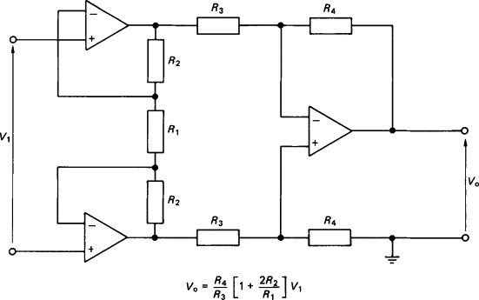Instrumentation amplifiers are precision devices having a high [input impedance](https://www.sciencedirect.com/topics/engineering/input-impedance), a low [output impedance](https://www.sciencedirect.com/topics/engineering/output-impedance), a high common-mode rejection ratio, a low level of self-generated noise and a low offset drift.

The first two amplifiers appearing in the input stage operate essentially as buffers, either with unity gain or with some finite value of gain.

A number of instrumentation amplifiers are packaged in IC form and these are suitable for the amplification of signals from strain gauges, thermocouples and other low-level differential signals from various [bridge circuits](https://www.sciencedirect.com/topics/engineering/bridge-circuits).

**VERIFICATION:**

Circuit Diagram

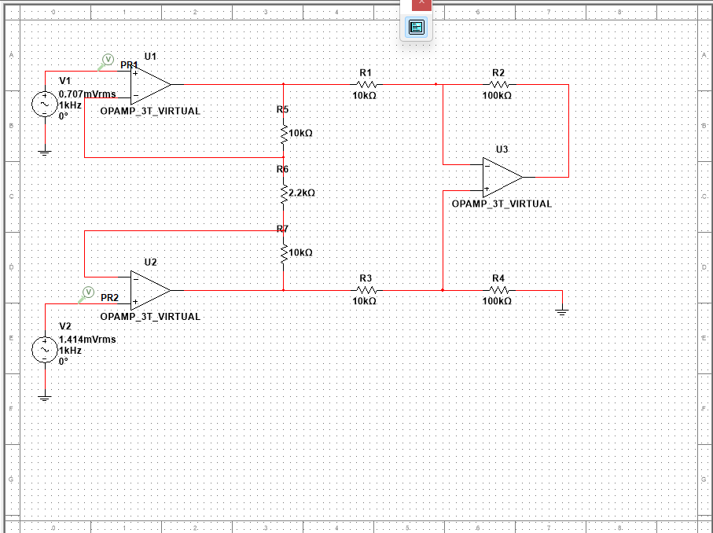

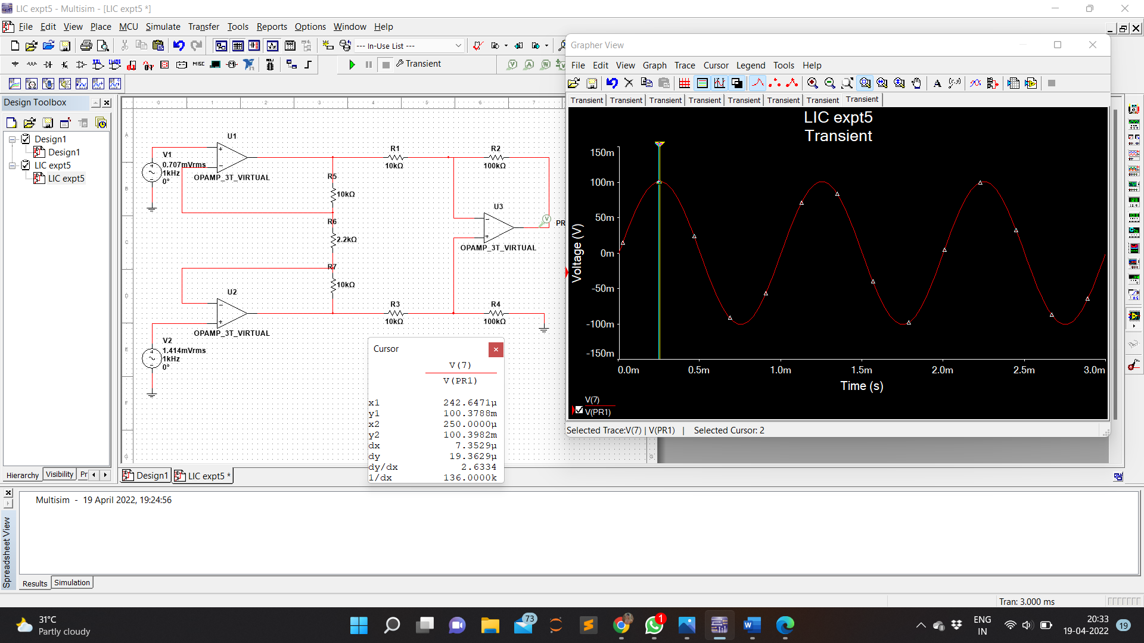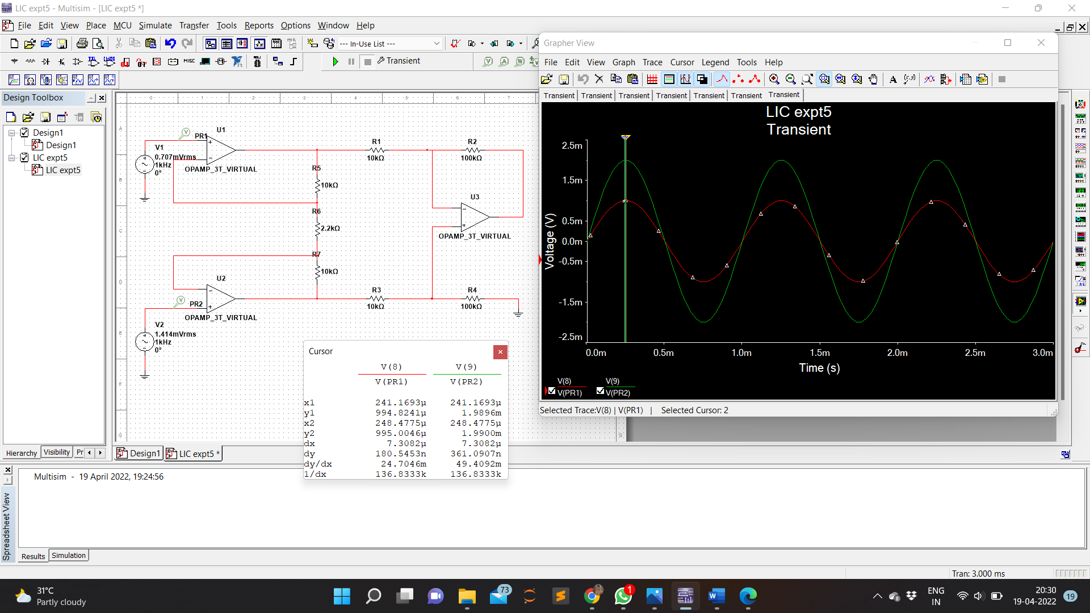Input Voltage

Output Voltage

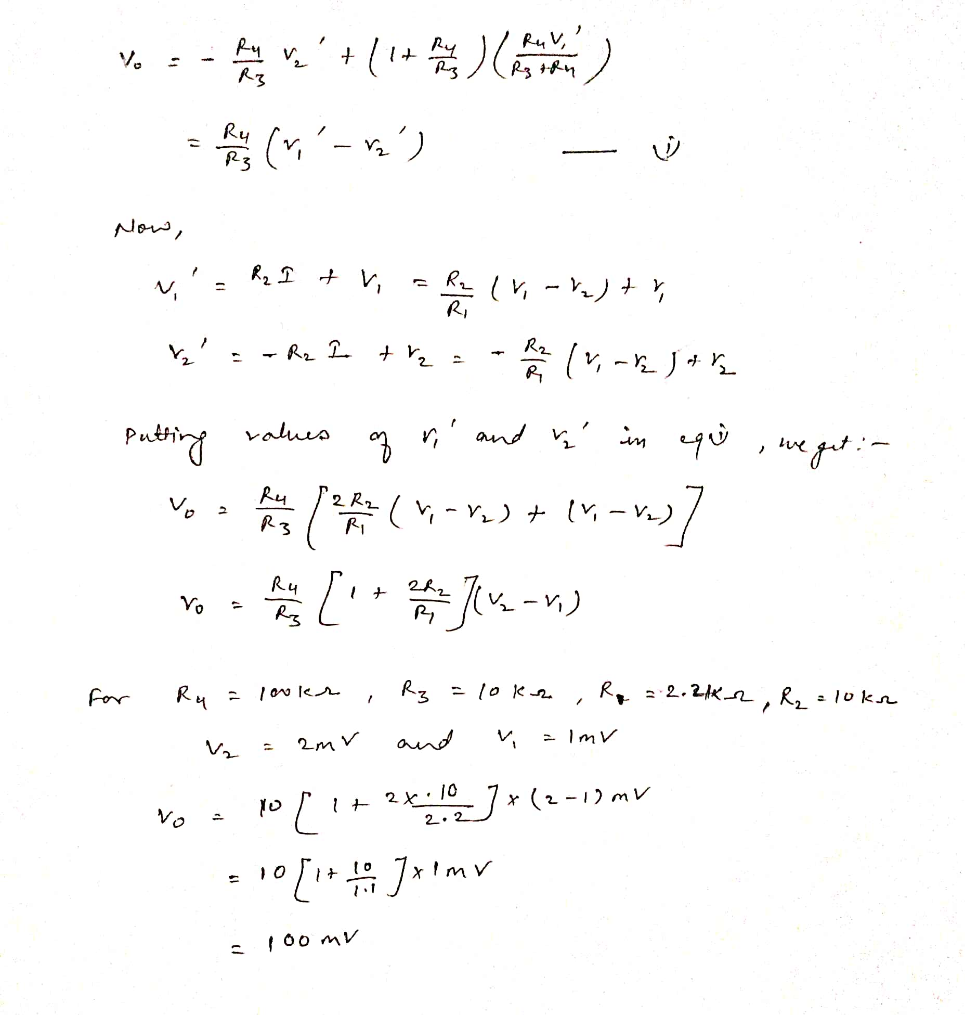Calculation

**RESULT:**

Instrumentation Amplifier was designed using multisim , simulated and verified